Week-1. Lists, Links and Images
a. Write a HTML program, to explain the working of lists.
Note: It should have an ordered list, unordered list, nested lists and ordered list in an
unordered list and definition lists.
Description:
In HTML, list tags are used to display a group of related items in a structured way. HTML provides different types of lists, each serving a specific purpose.
<ul> | - Creates an unordered list (bulleted).

<ol> | - Creates an ordered list (numbered or lettered).

<li> | - Defines a list item inside <ul> or <ol>.

<dl> | - Creates a description list (used for definitions or terms).

<dt> | - Defines a term/name in a description list.

<dd> | - Defines a description/detail for the term in <dt>.
Code: list.html
<!DOCTYPE html>
<html>
<head>
<title>HTML Lists Example</title>
</head>
<body>
<h1>Working with Lists in HTML</h1>
<!-- Ordered List -->
<h2>Ordered List</h2>
<ol>
<li>HTML</li>
<li>CSS</li>
<li>JavaScript</li>
</ol>
<!-- Unordered List -->
<h2>Unordered List</h2>
<ul>
<li>Apple</li>
<li>Banana</li>
<li>Cherry</li>
</ul>
<!-- Nested Lists -->
<h2>Nested List</h2>
<ol>
<li>Frontend
<ul>
<li>HTML</li>
<li>CSS</li>
<li>JavaScript</li>
</ul>
</li>
<li>Backend
<ul>
<li>Node.js</li>
<li>Python</li>
</ul>
</li>
</ol>

<!-- Ordered List inside Unordered List -->
<h2>Ordered List inside Unordered List</h2>
<ul>
<li>Web Technologies
<ol>
<li>HTML</li>
<li>CSS</li>
<li>JavaScript</li>
</ol>
</li>
<li>Database
<ol>
<li>MySQL</li>
<li>MongoDB</li>
</ol>
</li>
</ul>

<!-- Definition List -->
<h2>Definition List</h2>
<dl>
<dt>HTML</dt>
<dd>HyperText Markup Language</dd>
<dt>CSS</dt>
<dd>Cascading Style Sheets</dd>
<dt>JS</dt>
<dd>JavaScript – Scripting language for web pages</dd>
</dl>
</body>
</html>

Output:
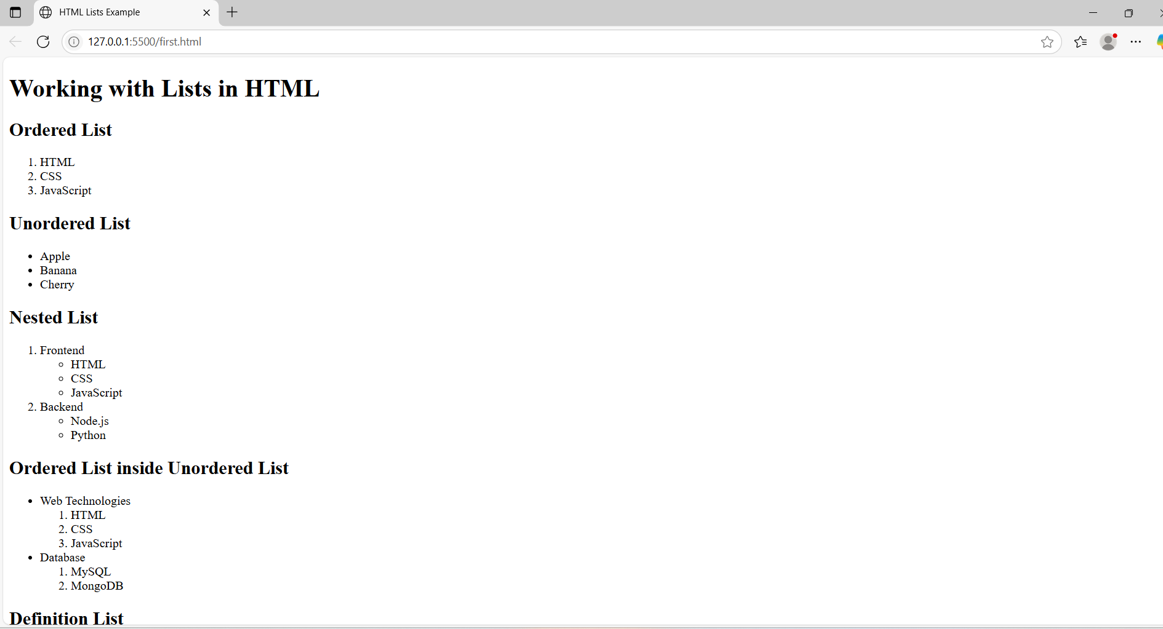

1 b) Write a HTML program, to explain the working of hyperlinks using <a> tag and href, target Attributes.
Note: Use text to link https://www.aec.edu.in/
Use image to link https://www.aec.edu.in/?p=Gallery
Description:
<a> (Anchor Tag):
Used to create hyperlinks to other web pages, email addresses, or files.
href (Hypertext REFerence):
Specifies the URL or link destination.
target Attribute:
Specifies where to open the linked document.
_blank opens the link in a new tab.
_self (default) opens in the same tab.
<img> (Image Tag):
Used to embed images in a web page.
src defines the image path.
alt provides alternative text if the image doesn't load.
width sets the image width in pixels.
Code:
<!DOCTYPE html>
<html>
<head>
<title>Hyperlink Example</title>
</head>
<body>
<h1>Working with Hyperlinks in HTML</h1>
<!-- Text Link -->
<h2>Text Hyperlink</h2>
<p>
Visit the official website of
<a href="https://www.aec.edu.in/" target="_blank">Aditya Engineering College</a>
for more information.
</p>

<!-- Image Link -->
<h2>Image Hyperlink</h2>
<p>Click the image below to visit the AEC Gallery:</p>
<a href="https://www.aec.edu.in/?p=Gallery" target="_blank">
<img src="test.PNG" alt="AEC Gallery" width="50" height="50">
</a>
</body>
</html>

Output:
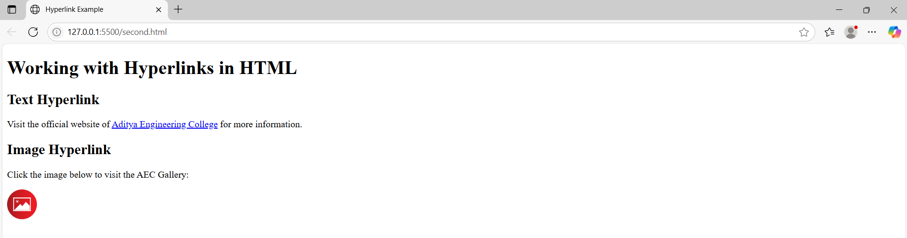

1 c)
<!DOCTYPE html>
<html>
<head>
<title>Profile Image Links</title>
</head>
<body>
<h1>My Profile and My Friend's Profile</h1>
<!-- Your Image -->
<a href="https://www.linkedin.com/in/your-profile" target="_blank">
<img src="first_person.jpg" alt="My Profile" width="100" height="100"> </a>
<p>Click on my image to visit my profile</p>
<!-- Friend's Image -->
<a href="https://www.linkedin.com/in/friends-profile" target="_blank">
<img src="second_pesron.jpeg" alt="Friend's Profile" width="100" height="100">
</a>
<p>Click on my friend's image to visit their profile</p>
</body>
</html>
Output:
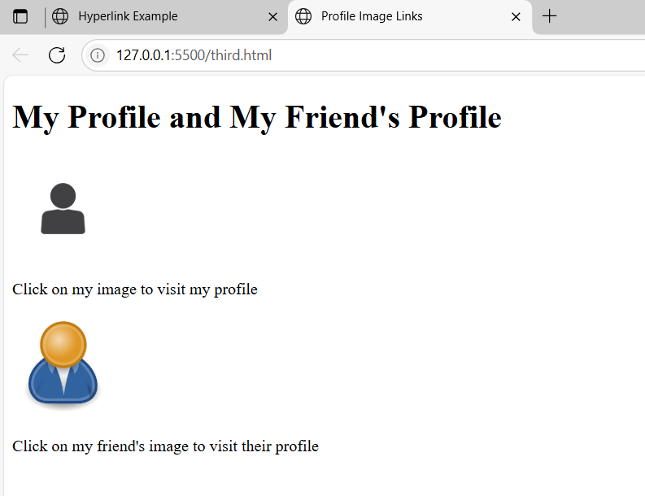
1 d)
<!DOCTYPE html>
<html>
<head>
<title>Thumbnail Image Gallery</title>
</head>
<body>
<h1>Thumbnail Image Gallery</h1>
<p>Click on any image to view the full-size version.</p>
<!-- Gallery Thumbnails -->
<a href="JBL.jpg" target="_blank">
<img src="JBL.jpg" width="100px" height="100px">
</a>
<a href="https://picsum.photos/id/1015/600/400" target="_blank">
<img src="https://picsum.photos/id/1015/100/100" alt="Image 1"> </a>
<a href="https://picsum.photos/id/1016/600/400" target="_blank">
<img src="https://picsum.photos/id/1016/100/100" alt="Image 2">
</a>
<a href="https://picsum.photos/id/1018/600/400" target="_blank">
<img src="https://picsum.photos/id/1018/100/100" alt="Image 3">
</a>
<a href="https://picsum.photos/id/1020/600/400" target="_blank">
<img src="https://picsum.photos/id/1020/100/100" alt="Image 4">
</a>
<a href="https://picsum.photos/id/1021/600/400" target="_blank">
<img src="https://picsum.photos/id/1021/100/100" alt="Image 5">
</a>
</body>
</html>
Output:
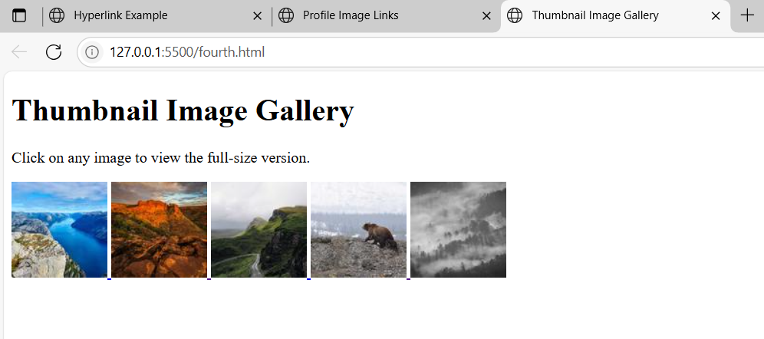

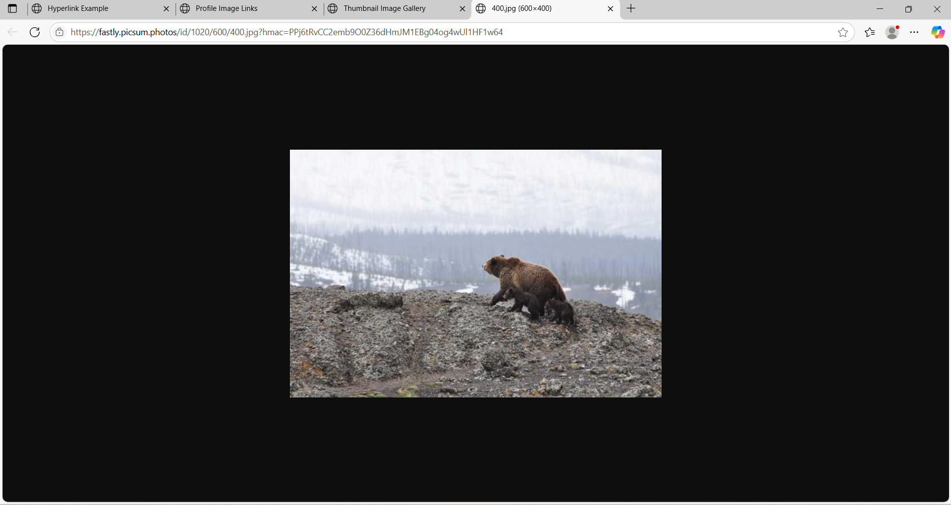

Viva Questions:
- What is the difference between <ol> and <ul>?
Ans) <ol> creates an ordered list with numbers or letters; <ul> creates an unordered list with bullets.
- Which tag is used to define a list item?
Ans) The <li> tag is used inside <ul> or <ol> to define a list item.
- How do you create a hyperlink in HTML?
Ans) By using the <a> tag. Example: <a href="https://example.com">Click here</a>.
- What attribute is required in the <a> tag to define the link?
Ans) The href attribute specifies the URL of the link.
- What is the use of the target="_blank" attribute in an anchor tag?
Ans) It opens the linked page in a new tab or window.
- Which tag is used to insert an image in HTML?
Ans) The <img> tag is used to embed an image.
- What are the required attributes of the <img> tag?
Ans) src (image URL) and alt (alternate text).
- Can we make an image clickable? If yes, how?
Ans) Yes, wrap the <img> tag inside an <a> tag.
Example: <a href="page.html"><img src="img.jpg" alt="Image"></a>
- What is the use of the <dl>, <dt>, and <dd> tags?
Ans) They create a description list:
- <dl>: starts the list
- <dt>: defines the term
- <dd>: gives the definition
- How can you display an image of fixed size?
Ans) Use width and height attributes.
Example: <img src="pic.jpg" width="200" height="100">

Week-2: Tables, Forms and Frames
2 a) Write a HTML program, to explain the working of tables. (use tags: <table>, <tr>, <th>, <td> and attributes: border, rowspan, colspan).
Description:
The <table> tag in HTML is used to create a table structure to display data in rows and columns.
Tag | - Purpose
<table> | - Starts the table structure.
<tr> | - Defines a table row.
<th> | - Defines a header cell (bold and centered by default).
<td> | - Defines a data cell (normal text).
<thead> | - Groups the header content. Helps in accessibility and styling.
<tbody> | - Groups the main body content of the table.
<tfoot> | - Groups the footer content, usually summary or totals.
<caption> | - Adds a title to the table (appears above the table).
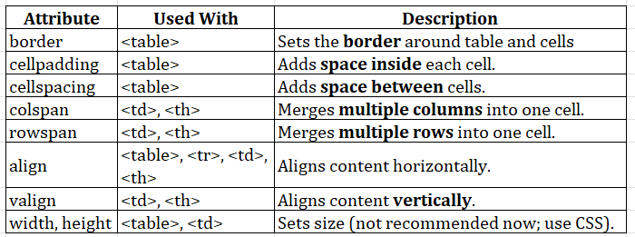

Code:
<!DOCTYPE html>
<html>
<head>
<title>Employee Information Table</title>
</head>
<body> <h1>Company Employee Information</h1>
<table border="1" cellpadding="10" cellspacing="0">
<!-- Table Header -->
<tr>
<th rowspan="2">Emp ID</th>
<th rowspan="2">Name</th>
<th rowspan="2">Department</th>
<th rowspan="2">Designation</th>
<th colspan="2">Contact Info</th>
<th rowspan="2">Salary</th>
<th rowspan="2">Address</th>
</tr>
<tr>
<th>Email</th>
<th>Phone</th>
</tr>
<!-- Employee 1 -->
<tr>
<td>EMP101</td>
<td>Alice Johnson</td>
<td>HR</td>
<td>Manager</td>
<td>alice.hr@company.com</td>
<td>9876543210</td>
<td>$60,000</td>
<td>New York, USA</td>
</tr>
<!-- Employee 2 -->
<tr>
<td>EMP102</td>
<td>Bob Smith</td>
<td>IT</td>
<td>Software Engineer</td>
<td>bob.it@company.com</td>
<td>9123456780</td>
<td>$80,000</td>
<td>San Francisco, USA</td>
</tr>
<!-- Employee 3 -->
<tr>
<td>EMP103</td>
<td>Charlie Lee</td>
<td>Finance</td>
<td>Analyst</td>
<td>charlie.finance@company.com</td>
<td>9988776655</td>
<td>$70,000</td>
<td>Chicago, USA</td>
</tr>
</table>
</body>
</html>
Output:
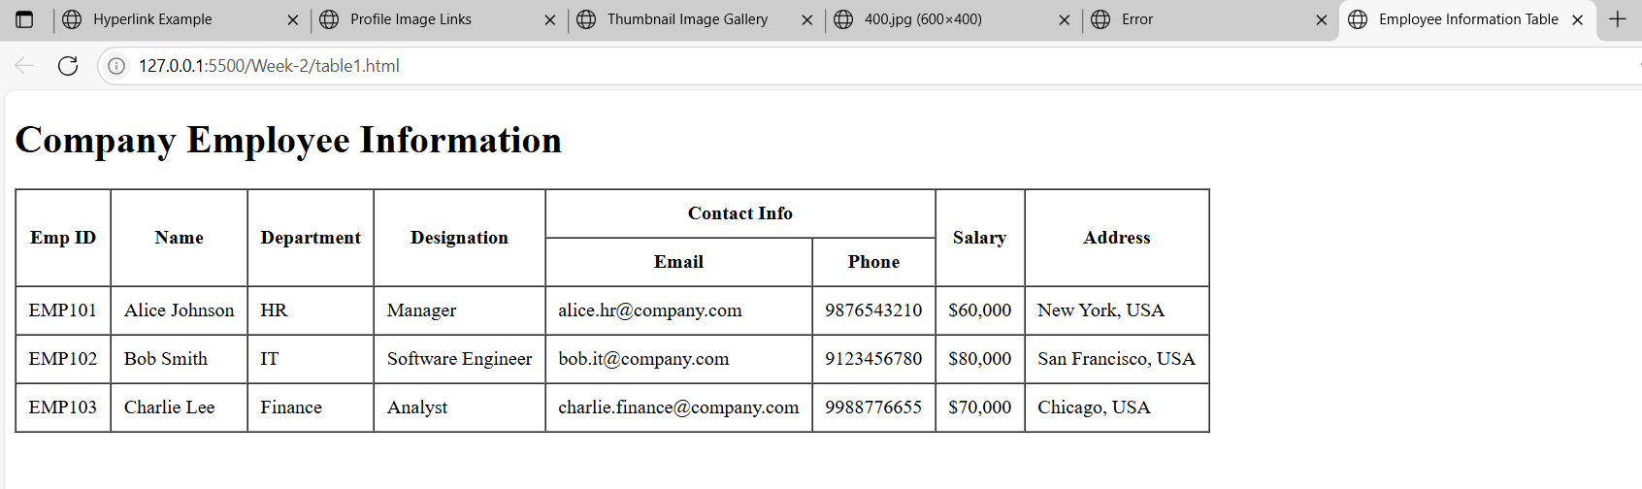

2 b) Write a HTML program, to explain the working of tables by preparing a timetable. (Note: Use <caption> tag to set the caption to the table & also use cell spacing, cell padding, border, rowspan, colspan etc.).
Code:
<!DOCTYPE html>
<html>
<head>
<title>B.Tech I Semester Timetable</title>
</head>
<body>
<h1 align="center">B.Tech I Semester Timetable</h1>
<table border="2" cellspacing="4" cellpadding="10" align="center">
<caption><strong>Department of Computer Science & Engineering</strong></caption>
<tr>
<th>Day</th>
<th>9:00 - 10:00</th>
<th>10:00 - 11:00</th>
<th>11:00 - 12:00</th>
<th>12:00 - 1:00</th>
<th>1:00 - 2:00</th>
<th>2:00 - 3:00</th>
<th>3:00 - 4:00</th>
</tr>
<!-- Monday -->
<tr>
<td>Monday</td>
<td>Mathematics-I</td>
<td>Physics</td>
<td>English</td>
<td rowspan="5" align="center"><strong>Lunch Break</strong></td>
<td>Python Programming</td>
<td>Engineering Graphics</td>
<td>Library</td>
</tr>
<!-- Tuesday -->
<tr>
<td>Tuesday</td>
<td>Engineering Chemistry</td>
<td>English</td>
<td>Workshop</td>
<td>Mathematics-I</td>
<td>Physics</td>
<td>Sports</td>
</tr>
<!-- Wednesday -->
<tr>
<td>Wednesday</td>
<td>Python Lab</td>
<td colspan="2">Python Programming Lab</td>
<td>English</td>
<td>Engineering Graphics</td>
<td>Mentoring Hour</td>
</tr>
<!-- Thursday -->
<tr>
<td>Thursday</td>
<td>Physics Lab</td>
<td colspan="2">Physics Laboratory</td>
<td>Engineering Chemistry</td>
<td>Mathematics-I</td>
<td>Workshop</td>
</tr>
<!-- Friday -->
<tr>
<td>Friday</td>
<td>Engineering Graphics</td>
<td>Physics</td>
<td>Mathematics-I</td>
<td>Python Programming</td>
<td>Library</td>
<td>Sports</td>
</tr>
</table>
</body>
</html>

Output:
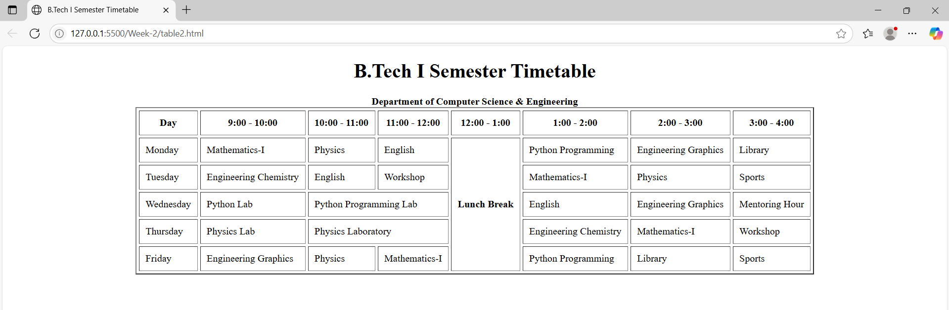

2 c) Write a HTML program, to explain the working of forms by designing Registration form.
(Note: Include text field, password field, number field, date of birth field, checkboxes, radio buttons, list boxes using <select>&<option> tags, <text area> and two buttons ie: submit and reset. Use tables to provide a better view).
Description:
The <form> tag is used to create an HTML form for collecting user input. Forms can be used to send data to a server, such as login information, feedback, survey responses, or file uploads.
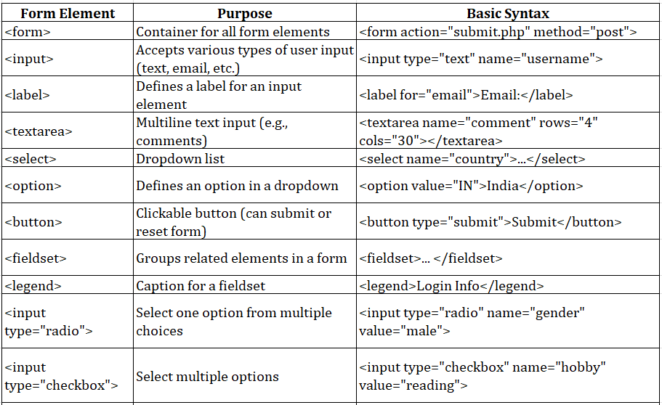
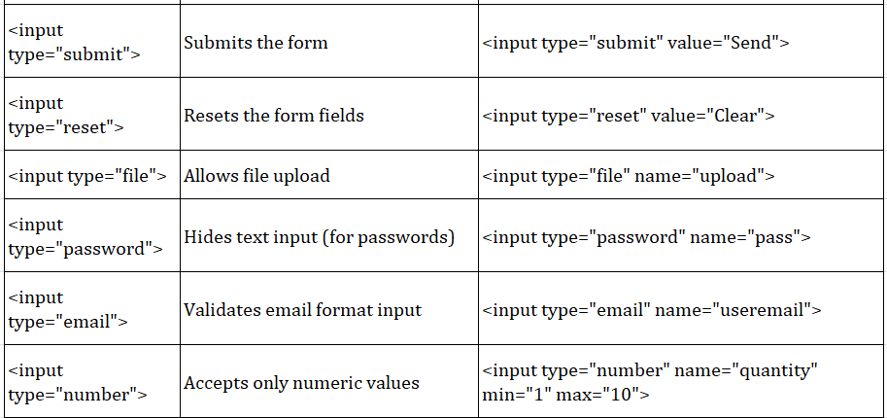
Important Attributes in <form>:
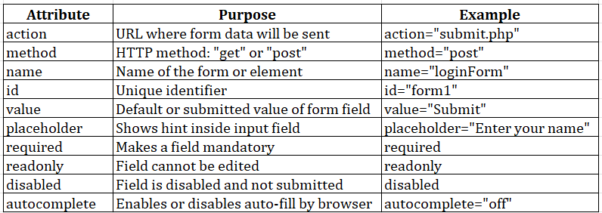
Code:
<!DOCTYPE html>
<html>
<head>
<title>Extended Student Registration Form</title>
</head>
<body>
<h2 align="center">Extended Student Registration Form</h2>
<form action="#" method="post" enctype="multipart/form-data">
<table border="1" cellpadding="10" cellspacing="0" align="center">
<caption><strong>Student Details</strong></caption>
<tr>
<th>Full Name:</th>
<td><input type="text" name="fullname" placeholder="Enter full name"
required></td>
</tr>
<tr>
<th>Email:</th>
<td><input type="email" name="email" placeholder="example@email.com"
required></td>
</tr>
<tr>
<th>Password:</th>
<td><input type="password" name="password" required></td>
</tr>
<tr>
<th>Mobile Number:</th>
<td><input type="tel" name="phone" pattern="[0-9]{10}" placeholder="10-digit
number" required></td>
</tr>
<tr>
<th>Age:</th>
<td><input type="number" name="age" min="17" max="30"></td>
</tr>
<tr>
<th>Date of Birth:</th>
<td><input type="date" name="dob"></td>
</tr>
<tr>
<th>Gender:</th>
<td>
<input type="radio" name="gender" value="Male"> Male
<input type="radio" name="gender" value="Female"> Female
<input type="radio" name="gender" value="Other"> Other
</td>
</tr>
<tr>
<th>Courses Interested:</th>
<td>
<input type="checkbox" name="course" value="C"> C
<input type="checkbox" name="course" value="C++"> C++
<input type="checkbox" name="course" value="Java"> Java
<input type="checkbox" name="course" value="Python"> Python
<input type="checkbox" name="course" value="Web"> Web Development
</td>
</tr>
<tr>
<th>Branch:</th>
<td>
<select name="branch">
<option value="">--Select Branch--</option>
<option value="CSE">Computer Science</option>
<option value="ECE">Electronics</option>
<option value="EEE">Electrical</option>
<option value="MECH">Mechanical</option>
<option value="CIVIL">Civil</option>
</select>
</td>
</tr>
<tr>
<th>College Website:</th>
<td><input type="url" name="website"
placeholder="https://www.example.com"></td>
</tr>
<tr>
<th>Address:</th>
<td><textarea name="address" rows="4" cols="30" placeholder="Enter your
address"></textarea></td>
</tr>
<tr>
<th>Upload Resume:</th>
<td><input type="file" name="resume"></td>
</tr>
<tr>
<th>Preferred Time Slot:</th>
<td><input type="time" name="timeslot"></td>
</tr>
<tr>
<th>Skill Level (0-10):</th>
<td><input type="range" name="skill" min="0" max="10"></td>
</tr>
<tr>
<th>Favorite Color:</th>
<td><input type="color" name="color"></td>
</tr>
<!-- Hidden Field -->
<tr>
<td colspan="2">
<input type="hidden" name="registration_type" value="student">
</td>
</tr>
<tr>
<th colspan="2" align="center">
<input type="submit" value="Submit">
<input type="reset" value="Reset">
</th>
</tr>
</table>
</form>
</body>
</html>
Output:
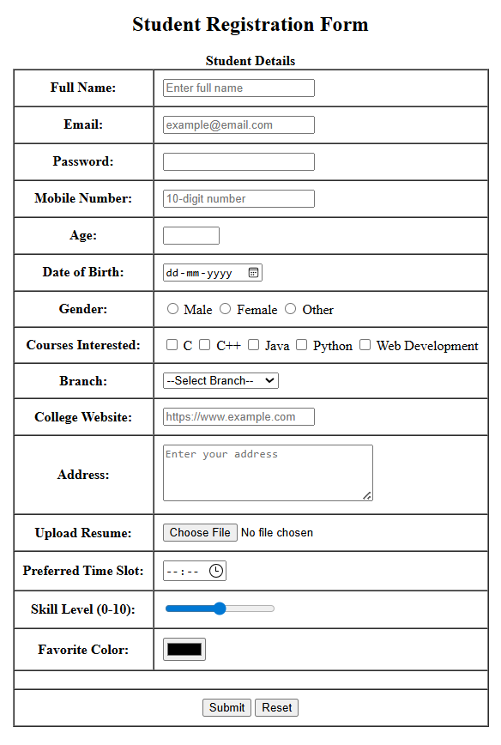
2 d) Write a HTML program, to explain the working of frames, such that page is to be divided into 3 parts on either direction. (Note: first frame image, second frame paragraph, third frame hyperlink. And also make sure of using “no frame” attribute such that frames to be fixed).
Description:
The <frameset> tag was used in HTML 4 to divide the browser window into multiple frames, each capable of displaying a different HTML document simultaneously. It replaces the <body> tag and allows developers to create a multi-pane view in one browser window.
Purpose of <frameset>:
- To split the web page into rows or columns.
- To load multiple documents at the same time within one page.
- To enable side-by-side navigation, like menus and content areas.
Code:
image.html:
<!DOCTYPE html>
<html>
<head>
<title>Image Frame</title>
</head>
<body>
<h2 align="center">Welcome to Our Site</h2>
<div align="center">
<img src="people.jpeg" alt="Sample Image" width="600">
</div>
</body>
</html>
paragraph.html:
<!DOCTYPE html>
<html>
<head>
<title>Paragraph Frame</title>
</head>
<body>
<h3 align="center">About Us</h3>
<p align="justify" style="padding: 10px;">
This website demonstrates the usage of HTML frames by dividing the layout into three horizontal sections.
The first frame shows an image, the second frame provides some descriptive text, and the third frame lists useful links.
Frames are used to present multiple HTML documents within a single browser window.
</p>
</body>
</html>
links.html:
<!DOCTYPE html>
<html>
<head>
<title>Links Frame</title>
</head>
<body>
<h3 align="center">Useful Links</h3>
<ul style="text-align: center; list-style-type: none;">
<li><a href="https://www.google.com" target="_blank">Google</a></li>
<li><a href="https://www.wikipedia.org" target="_blank">Wikipedia</a></li>
<li><a href="https://www.w3schools.com" target="_blank">W3Schools</a></li>
</ul>
</body>
</html>

framesetdemo.html:
<!DOCTYPE html>
<html>
<head>
<title>Frameset Example</title>
</head>
<frameset rows="30%,40%,30%">
<frame src="image.html" name="frame1">
<frame src="paragraph.html" name="frame2">
<frame src="links.html" name="frame3">
<noframes>
<body>
<p>This page uses frames but your browser does not support them.</p>
</body>
</noframes>
</frameset>
</html>
Output:
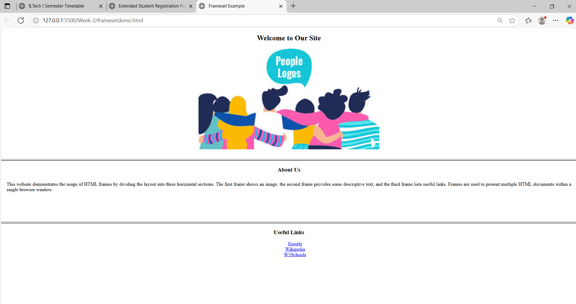
Viva Questions:
  - What is the use of the <table> tag?
Ans) It creates a table to display data in rows and columns.
  - What is the difference between <th> and <td>?
Ans) <th> is a header cell (bold), <td> is a normal cell.
  - Which tag is used to give a title to a table?
Ans) <caption> is used to add a title to the table.
  - What is the default alignment of <th> text?
Ans) Center aligned and bold.
  - What is the use of colspan?
Ans) It merges two or more columns into one cell.
  - What is the use of rowspan?
Ans) It merges two or more rows into one cell.
  - What does cellpadding do?
Ans) It adds space inside the table cell.
  - What does cellspacing do?
Ans) It adds space between the table cells.
Working with Forms
  - What is the purpose of the <form> tag in HTML?
Ans) The <form> tag is used to create a form that collects user input and sends it to a server.
  - What are the two main attributes of the <form> tag?)
Ans) action: URL where the form data is sent
method: HTTP method (GET or POST) used to submit the form
  - What is the use of the <input> tag?)
Ans) The <input> tag is used to create various input fields like textboxes, checkboxes, radio buttons, etc.
  - What is the difference between radio and checkbox inputs?
Ans) radio: allows only one option to be selected from a group and checkbox: allows multiple options to be selected
  - What is the use of the <select> and <option> tags?
Ans) <select> creates a dropdown menu and <option> defines each choice in the dropdown
  - What does the required attribute do in form fields?
Ans) It makes the input field mandatory, so the form can't be submitted without filling it.
Working with Frameset:
  - What is the purpose of the <frameset> tag in HTML?
Ans) The <frameset> tag is used to divide the browser window into multiple sections (frames), where each frame can display a different HTML document.
  - What attribute is used in <frameset> to split the window vertically?
Ans) The cols attribute is used to divide the screen into vertical frames (columns).
Example: <frameset cols="30%,70%">
  - What attribute is used in <frameset> to split the window horizontally?
Ans) The rows attribute is used to divide the screen into horizontal frames (rows).
Example: <frameset rows="50%,50%">
  - Which tag is used inside <frameset> to define each frame?
Ans) The <frame> tag is used to define each frame and load separate documents.
  - How do you load a webpage in a frame?
Ans) Use the src attribute in the <frame> tag.
Example: <frame src="menu.html">
  - What is the use of the noresize attribute in <frame>?
Ans) It prevents the user from resizing the frame manually.

